**Project Identification**

|  |  |
| --- | --- |
| **Project:** | CultureConnect |
| **Prepared By:** | Duy Hao Bui |
| **Document Version:** | CC 1.0 |
| **Published Date:** | Sept 3rd, 2018 |

**Contributors**

The following individuals contributed to this document.

| **Name** | **Title** |
| --- | --- |
| Youquan Liu | team leader |
| Duy Hao Bui | *team* |
| Anthony Caldwell | *team* |
| Ryan Haberle | *team* |
| Qian Wang | *team* |

**Distribution**

This document is distributed to all the following people.

| **Name** | **Title** |
| --- | --- |
|  |  |
|  |  |

**Referenced Documents**

This document refers to the following materials

|  |  |  |  |  |
| --- | --- | --- | --- | --- |
| **Version number** | **Title** | **Author** | **Date** | **Source / Location** |
|  |  |  |  |  |
|  |  |  |  |  |
|  |  |  |  |  |

**Revision History**

|  |  |  |  |
| --- | --- | --- | --- |
| **Version Number** | **Revision Date** | **Summary of Changes** | **Modified by** |
|  |  |  |  |
|  |  |  |  |
|  |  |  |  |

[Note: It is recommended that drafts be numbered 0.1 to 0.9, and that the first approved version be numbered 1.0. Thereafter, new version numbers will depend upon changes: 1.01, 1.1, etc for minor updates, 2.0, 3.0 etc for major changes.]

*TABLE OF CONTENTS*

1. Business Context Diagram 3

2. REquirements Scope Statements 4

3. High Level Business Requirements (HLR) Traceability 4

4. High Level Business Requirements Sign-Off 5

1. Business Context Diagram

<Insert Diagram>

|  |  |
| --- | --- |
| **Requirement Scope Area** | **Description** |
| Cultural connection app | Application responsible for providing a way for users and organizations to expand and explore new cultures.0.1 |

|  |  |
| --- | --- |
| **External Entity** | **Description** |
| Users. | The users of the site who can create, read, upload and delete events. Upload their info, events and preferences |
| Organizations. | The users of the site who can create, read, upload and delete events. Send preferences for site. Sends organization info. |
| Data Base | Where users info and organizational info is stored. |
| Site Admins | Update and monitor site, listen to users feedback |

| **Information Flows** | **Description** |
| --- | --- |
| Event info | Users/organizations send details about events to other users. Users create, read upload and delete even info on feeds and calendars. They can update their profiles and preferences |
| Preferences | Users\organizations send preferences for the site. |
| Alerts and confirmations. | Users are sent alerts by the app alerted that their invited have been accepted |
| User account info | Stored and sent by database. |
| Edit and maintenance of site | Admins will maintain site and listen to user feedback about the site. |

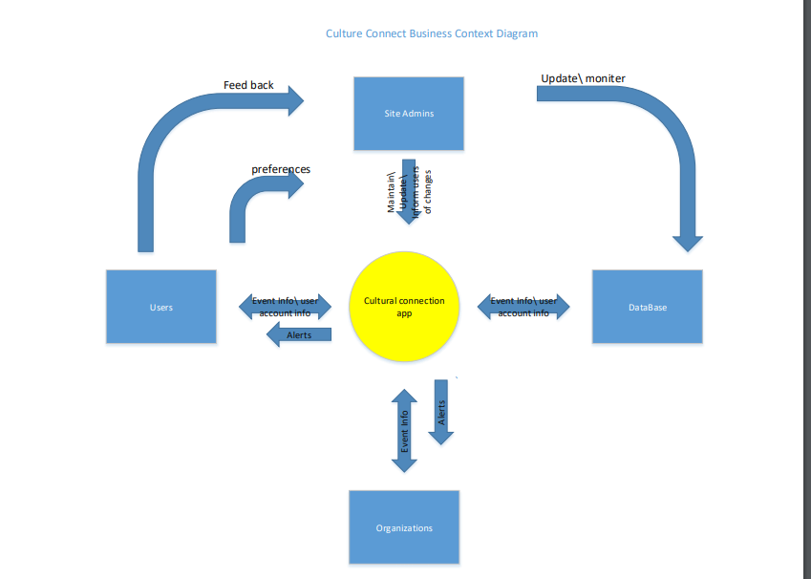

1. Requirements Scope Statements

|  |  |  |
| --- | --- | --- |
| **HLR#** | **Description** | **Priority**  **(H, M, L)** |
|  | User must create an account for creating and joining events | H |
|  | Event attendant will receive a survey after every post event | M |
|  | Event attendant will receive a report after every post event | L |
| HLR04 | Event attendant will receive a notifications after creating an account or join events | M |
| HLR05 | Event attendant will send a request for joining event, if the amount is full, they will be on a wait-list. | H |
| HLR06 | Event attendant can cancel the event they joined | M |
| HLR07 | Event creator can assign the amount of attendee | H |
| HLR08 | Event creator can accept or refuse joining request event | M |
| HLR09 | Event creator will receive a report about the event include the amount of attendant and rating | L |
| HLR10 | User can locate the event | H |
| HLR11 | User can make friends with others | M |
| HLR12 | User have a messenger for chatting | H |
| HLR13 | User have a calendar for tracking and reminding events | H |

1. High Level Business Requirements Sign-Off

The undersigned acknowledge their agreement with the contents of Version <x.x> of the High-Level Requirements document for <Project Name>.

Following approval of this document, requirements changes will be governed by the project’s change management process, including impact analysis and appropriate reviews and approvals, under the general control of the Project Plan and according to company policy. Approved Change Request Documents, if present, will be attached to this Requirements Document as updates.

|  |  |  |
| --- | --- | --- |
| **Names** | **Project Role and**  **Functional Area** | **Date Signed** |
| Youquan Liu | Team Leader | Sept 3rd, 2018 |
| Duy Hao Bui | Team | Sept 3rd, 2018 |
| Anthony Caldwell | Team | Sept 3rd, 2018 |
| Ryan Haberle | Team | Sept 3rd, 2018 |
| Qian Wang | Team | Sept 3rd, 2018 |

* Note: physical signatures are not required. Email approvals are acceptable and should be appended to project documents.